|  |  |
| --- | --- |
| Training Management System | Software Requirement Specification |
| **Design Model**  Khalid Shifullah  J2EE  Version ID Date: 07/07/2023  Document ID: SWD/ 01  Version ID: 1.0 | |
|  | |

Contents

1. Introduction 4

2. Use Case Diagrams 4

3. Entity Relationship Diagram (ER) 5

3.1. ER diagram with properties 6

3.2. ER diagram without properties 7

4. Activity Diagram 7

4.1. Classroom Feature 8

4.2. Batch and Course Feature 9

4.3. Assignment Feature 10

5. Dataflow Diagram (DFD) 10

5.1. Batch Creation 11

5.2. Classroom Feature 11

5.3. Assignments Feature 12

6. Conclusion 13

# **Introduction**

The following documentation provides an overview of the UML (Unified Modeling Language) diagrams used in the training management system (TMS). The diagrams include an Entity-Relationship (ER) diagram, Use Case diagram, Activity diagram, and Data Flow diagram. These diagrams are designed to represent various aspects of the system, such as the registration process, batch creation, course management, assignment creation, classroom features, submission of assignments, and group chat functionality.

# **Use Case Diagrams**

A Use Case Diagram is a visual representation of the interactions between actors (users or external systems) and the system under consideration. It illustrates the functionalities or behaviors provided by the system from the perspective of the users. In the Training Management System (TMS) Use Case Diagram, the main actors are the Admin, Trainers, and Trainees.

The Admin is responsible for managing registrations of Trainers and Trainees, creating batches, creating courses, and assigning Trainers and Trainees to specific batches. They can also schedule batches and manage the creation of assignments or daily tasks. Additionally, the Admin oversees the management of classroom features, including posting messages/files/comments, searching/filtering data, and managing a notice board.

The Trainers utilize the system to create assignments or daily tasks, use classroom features to post messages/files/comments, view assignment submissions, and participate in group chat communication. Trainees, on the other hand, can access the system to view classroom messages/files/comments, submit assignments, and participate in group chat communication.

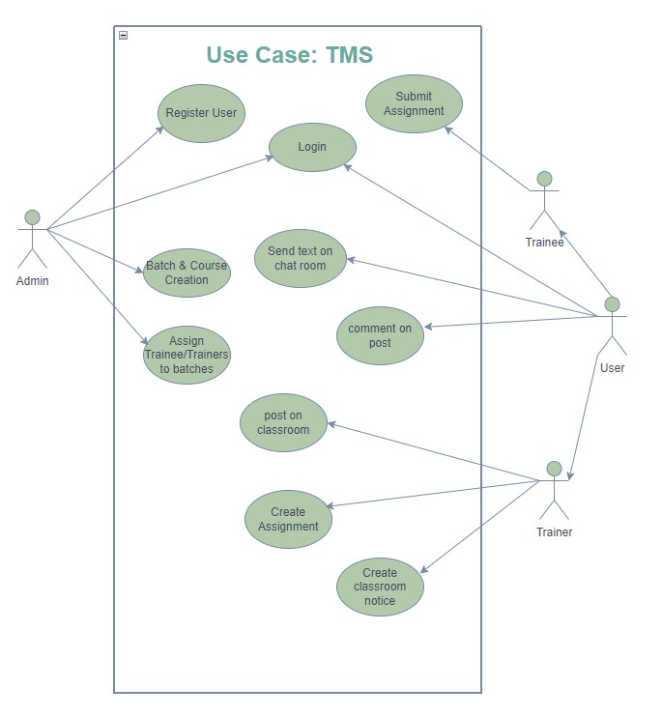

# **Entity Relationship Diagram (ER)**

The Entity-Relationship (ER) diagram is important as it visually represents the database schema, showing the entities, attributes, and relationships between them. It helps to understand the structure of the database and its logical organization, facilitating effective communication between stakeholders.

In the provided design, the ER diagram captures the key entities such as User, Batch, Course, Trainee, Trainer, Assignment, Submission, ClassroomPost, ClassroomComment, GroupChat, and ChatMessage. It illustrates the relationships between these entities, including one-to-one, one-to-many, and many-to-many relationships, enabling a comprehensive view of the system's data model.

# **ER diagram with properties**

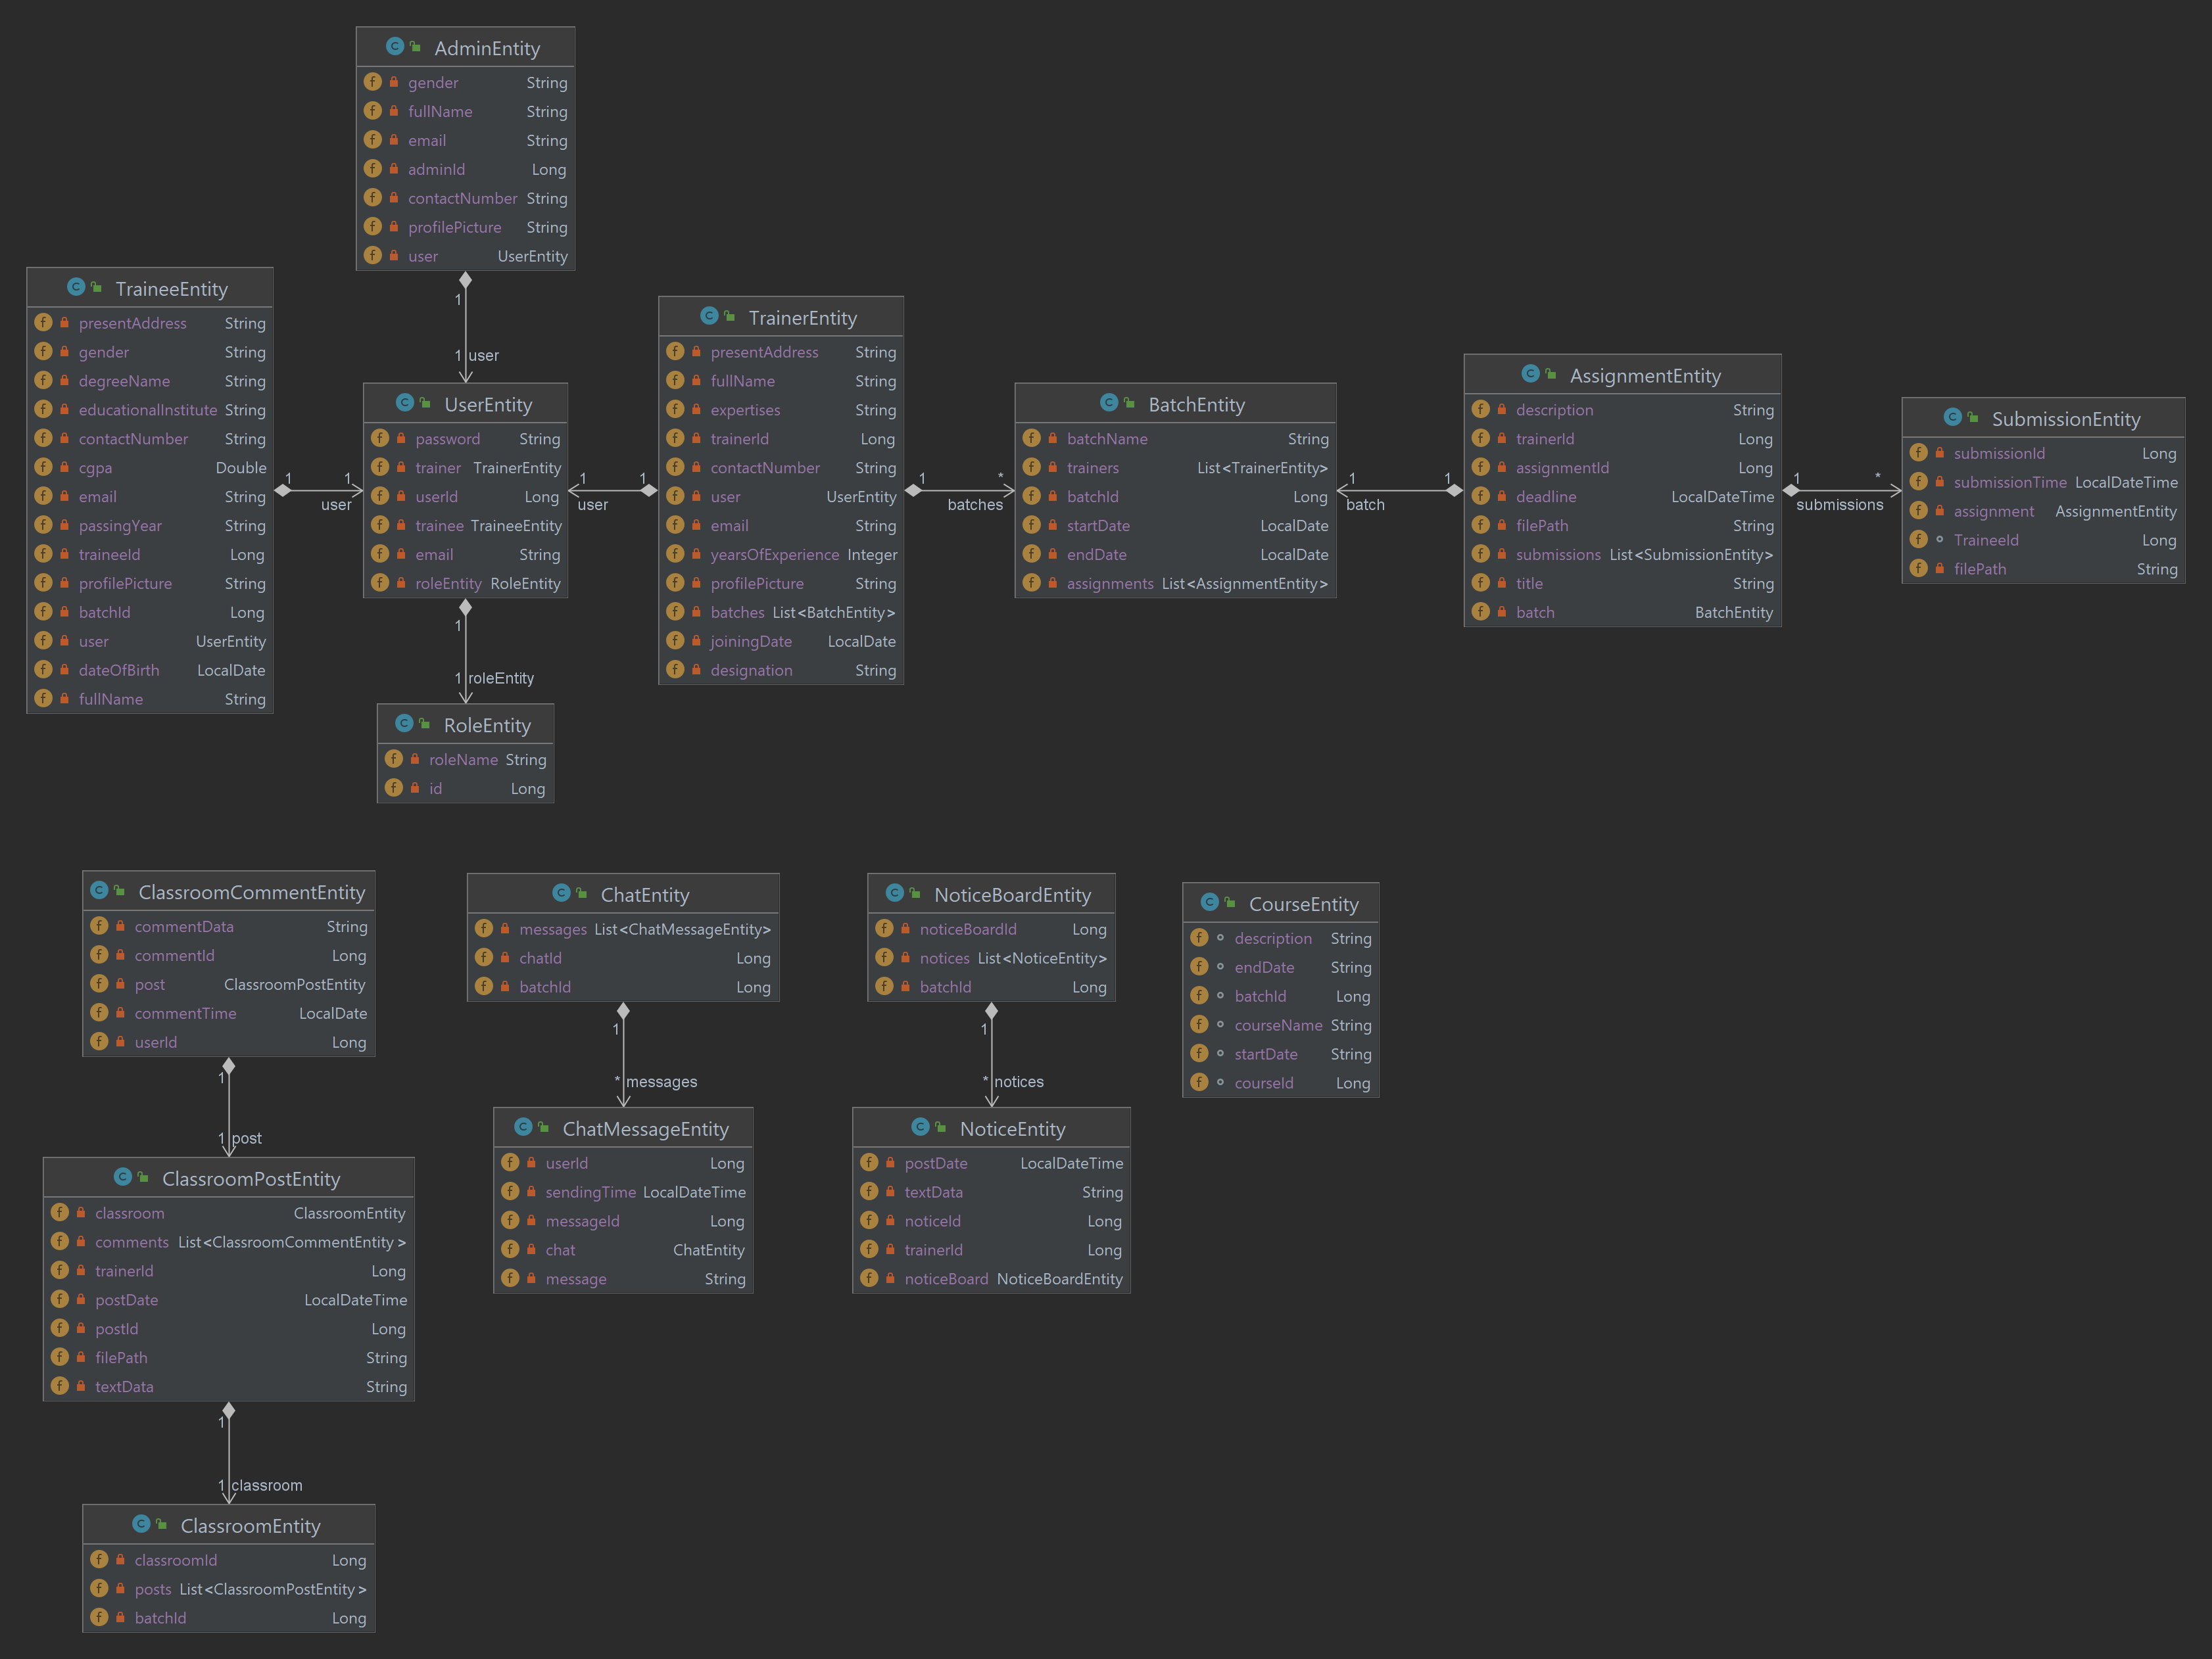

# **ER diagram without properties**

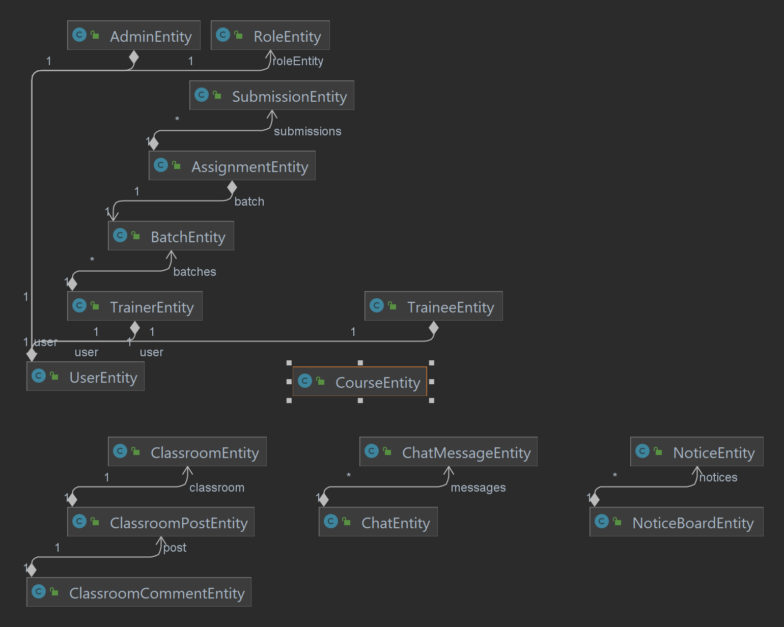

# Activity Diagram

An Activity Diagram is a behavioral diagram that depicts the flow of activities and actions within a system or process. It is important in software development as it provides a visual representation of the sequential and parallel activities, decision points, and control flows in a system. Activity diagrams help in understanding the overall workflow, identifying potential bottlenecks or inefficiencies, and facilitating communication between stakeholders. In the Training Management System (TMS) project, the Activity Diagrams capture the step-by-step flow of activities, such as registration, batch creation, course assignment, assignment creation, submission, and classroom interactions. These diagrams aid in visualizing the processes, identifying dependencies, and ensuring efficient execution of the system.

# **Classroom Feature**

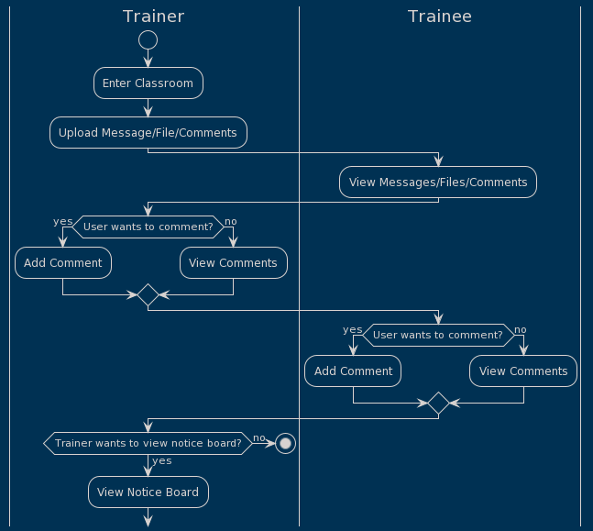

# Batch and Course Feature

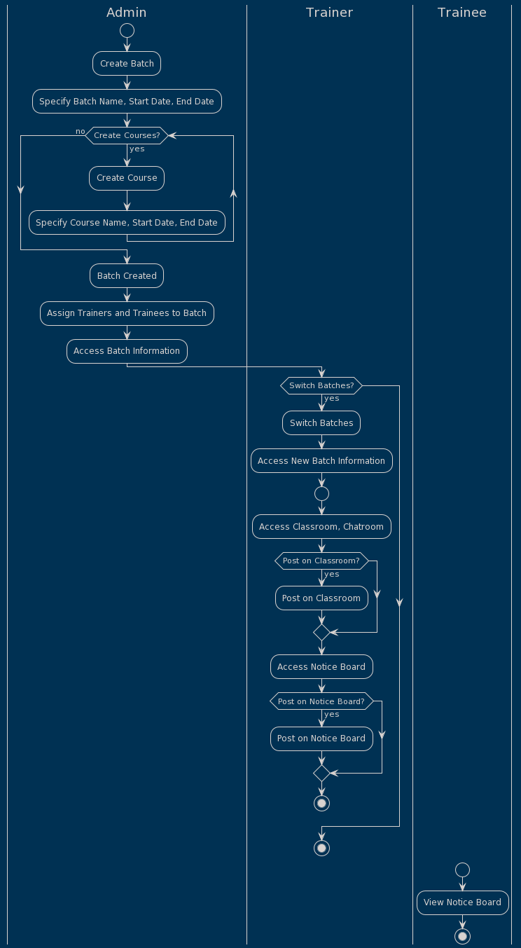

# Assignment Feature

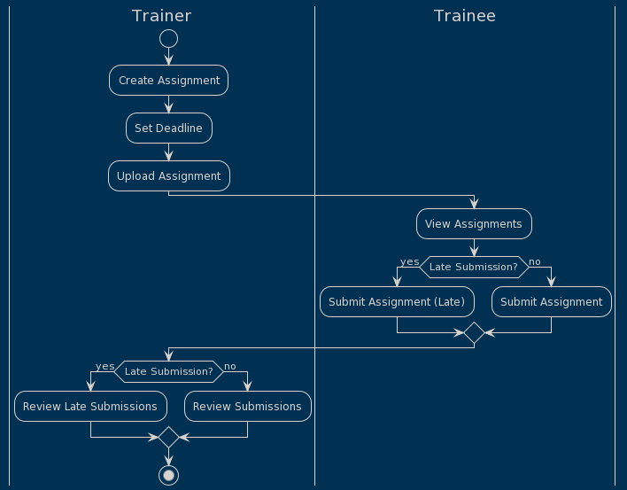

# Dataflow Diagram (DFD)

A Data Flow Diagram (DFD) is a graphical representation of the flow of data within a system. It is an essential tool in software development as it helps in visualizing andunderstanding how data moves through various processes, entities, and data stores.

# Batch Creation

This DFD illustrates the creation and management of batches. The Admin creates batches, which triggers the automatic creation of a classroom, chatroom, and assignment section specific to each batch. The Admin can assign trainers and trainees to specific batches, and trainers and trainees can access the corresponding classrooms, chatrooms, and assignment sections. The Data Store is responsible for storing batch details, relationship details, classroom details, chatroom details, and assignment section details.

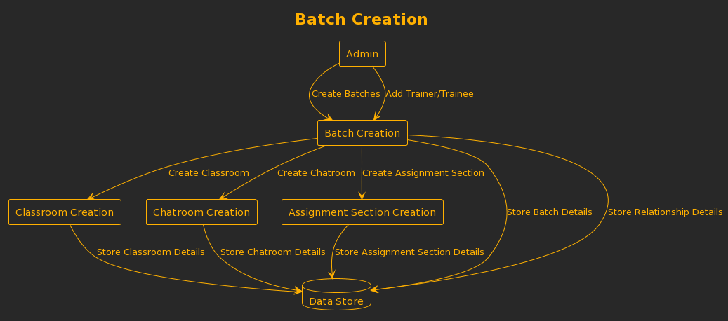

# Classroom Feature

This DFD illustrates the flow of data and interactions in the Classroom Module. Trainers can upload messages, files, and comments, which are stored in the Data Store. The data is shown in date-wise order, and trainees can search and filter the data. Both trainers and trainees can comment on the posts made by trainers. Additionally, trainers can manage the notice board. The Data Store is responsible for storing messages, files, comments, and notices.

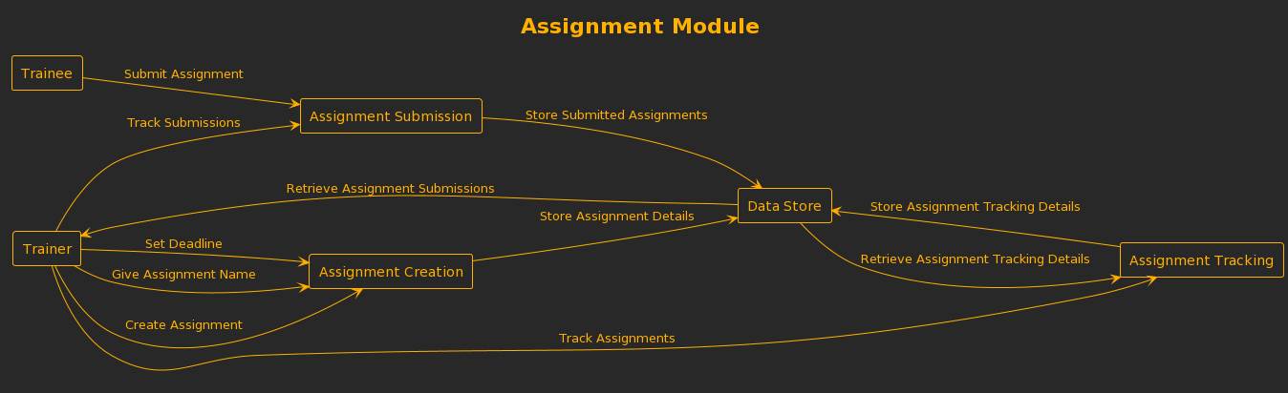

# Assignments Feature

This DFD represents the process of assignment management. Trainers create assignments with deadlines and assign them to specific batches. Trainees submit their assignments, which are then stored in the Data Store along with the submission details. Trainers can view the assignment submissions. Trainees have the ability to submit files in various formats like PDF, DOC, Word, and PNG.



# Conclusion

# In conclusion, the provided documentation offers a concise overview of the Training Management System (TMS) using various UML diagrams. These diagrams, including Use Case, ER, Activity, and DFD, provide a comprehensive understanding of the system's functionalities, interactions, and data flow. They serve as valuable tools for communicating and understanding the TMS's design and functionality, facilitating effective collaboration between stakeholders.